**Forest Cover Classification**

**Dataset:**  <https://www.kaggle.com/uciml/forest-cover-type-dataset>

**15120 examples with 7 classes. 2160 examples in each class Balanced classes.**

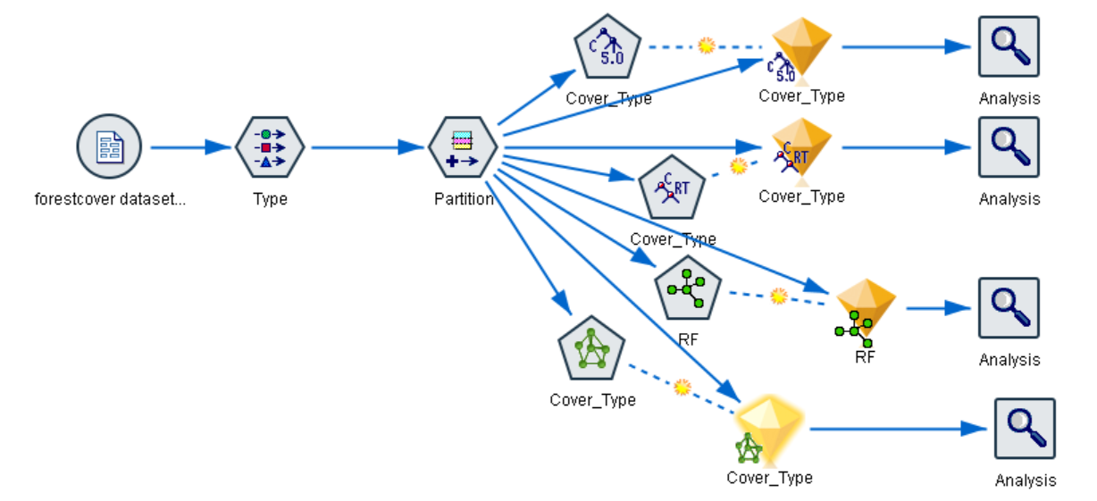

**Results below are from C5.0 classifier in SPSS Modeler (80/20 split)**

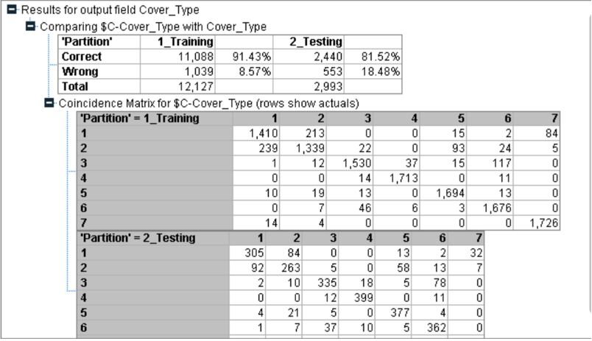

**The results below are from C&RT in SPSS Modeler (80/20 split)**

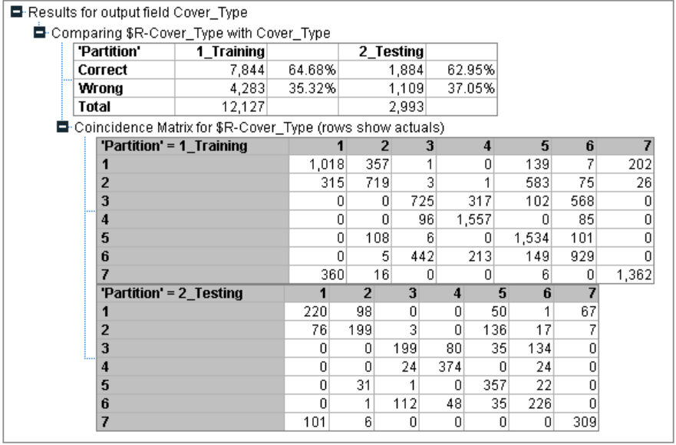

**Results below are from an ANN Model in SPSS Modeler (80/20 split)**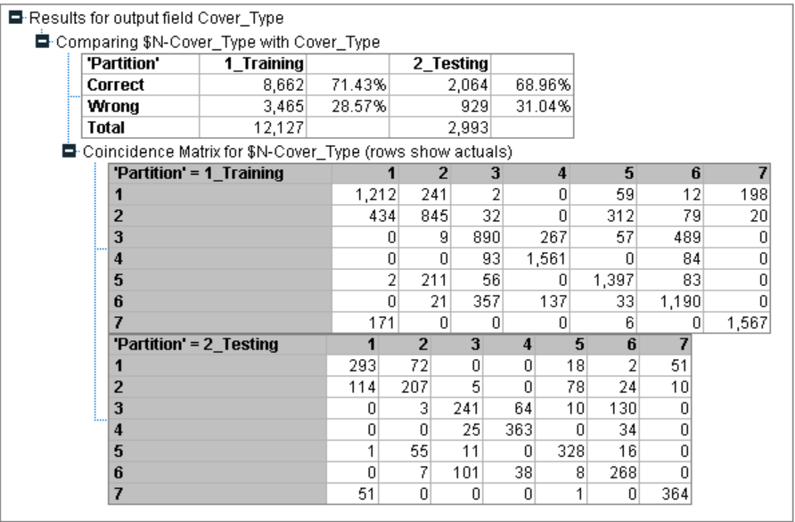

**Random Forest classifier with # trees = 11**

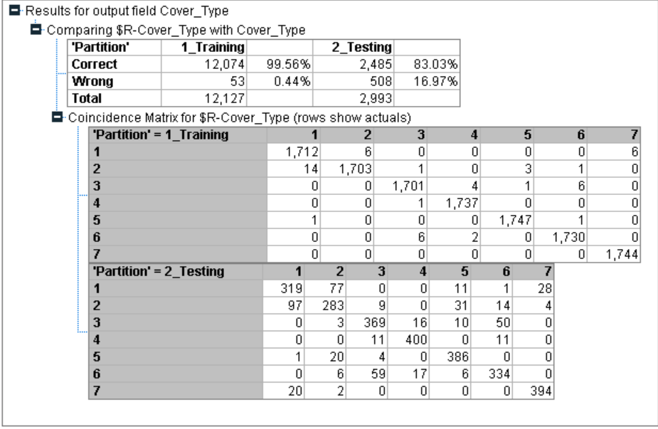

Dr. Brieman has established that the Random Forest algorithm does not overfit. So, even if we increase the number of trees (estimators) in the ensemble, it will not lead to overfitting.

**Random Forest Evaluation (in SPSS Modeler) with number of trees = 25**

